DEPARTMENT OF ROADS AND TRANSPORT
CONSULTING ENGINEERING SERVICES FOR
THE DESIGN WORK FOR THE PROVISION OF PUBLIC TRANSPORT AND ROAD INFRASTRUCTURE FOR THE LEOLO MOUNTAIN VILLAGE COMMUNITY, IN THE SEKHUKHUNE DISTRICT OF LIMPOPO

TENDER DOCUMENT:

TENDERER: _________________________________________________

AMOUNT TENDERED: _______________________________________
AMOUNT IN WORDS: ________________________________________
________________________________________

TENDER CLOSURE DATE: ____________________________
Issued by:
Prepared by:


SBD 1
INVITATION TO BID

YOU ARE HEREBY INVITED TO BID FOR REQUIREMENTS OF THE (DEPARTMENT OF ROADS AND TRANSPORT)

BID NUMBER: ___________ CLOSING DATE: ________________ CLOSING TIME: ________

DESCRIPTION: CONSULTING ENGINEERING SERVICES FOR THE PROVISION OF PUBLIC TRANSPORT AND ROAD INFRASTRUCTURE FOR THE LEOLO MOUNTAIN VILLAGE COMMUNITY, IN THE SEKHUKHUNE DISTRICT OF LIMPOPO.

DURATION OF THE CONTRACT: __________ (____) MONTHS – FROM: ________________ TO _________________

The successful bidder will be required to fill in and sign a written Contract Form (SBD 7).

BID DOCUMENTS TO BE DEPOSITED IN THE BID BOX SITUATED AT 40 KRUGER STREET AND 39 CHURCH STREET, POLOKWANE.

BIDDERS SHOULD ENSURE THAT BIDS ARE DELIVERED TIMEOUSLY TO THE CORRECT ADDRESS. IF THE BID IS LATE, IT WILL NOT BE ACCEPTED FOR CONSIDERATION.

The bid box is generally open 24 hours a day, 7 days a week.

ALL BIDS MUST BE SUBMITTED ON THE OFFICIAL FORMS – (NOT TO BE RE-TYPED)

THIS BID IS SUBJECT TO THE GENERAL CONDITIONS OF CONTRACT (GCC) AND, IF APPLICABLE, ANY OTHER SPECIAL CONDITIONS OF CONTRACT

THE FOLLOWING PARTICULARS MUST BE FURNISHED

(FAILURE TO DO SO MAY RESULT IN YOUR BID BEING DISQUALIFIED)

NAME OF BIDDER: ………………….…………………………………………………………………………

POSTAL ADDRESS: ……………………………………………………………………………………..…….

STREET ADDRESS: ……………………………………………………………………………………………

TELEPHONE NUMBER: CODE……………NUMBER……………………………………………………..

CELLPHONE NUMBER : ………………………………………………………………………………………

FACSIMILE NUMBER: CODE …………...NUMBER…………………………………………………………

VAT REGISTRATION NUMBER: ………………………………………………………………………………

HAS A TAX CLEARANCE CERTIFICATE BEEN SUBMITTED (SBD 2)? YES/NO

ARE YOU THE ACCREDITED REPRESENTATIVE IN SOUTH AFRICA FOR THE GOODS/SERVICES OFFERED BY YOU? YES/NO
(IF YES ENCLOSE PROOF)

SIGNATURE OF BIDDER ……………………………………………………………………………………..

DATE……………………………………………………………………………………………………………….

CAPACITY UNDER WHICH THIS BID IS SIGNED …………………………………………………………

TOTAL BID PRICE: ……………………… (…………………………………………………………………)

TOTAL BID PRICE BREAKDOWN:

DESIGN (Lump sum): ……………………… (…………………………………………………………………)

SUPERVISION (Monthly Rate): ……………… (……………………………………………………………)

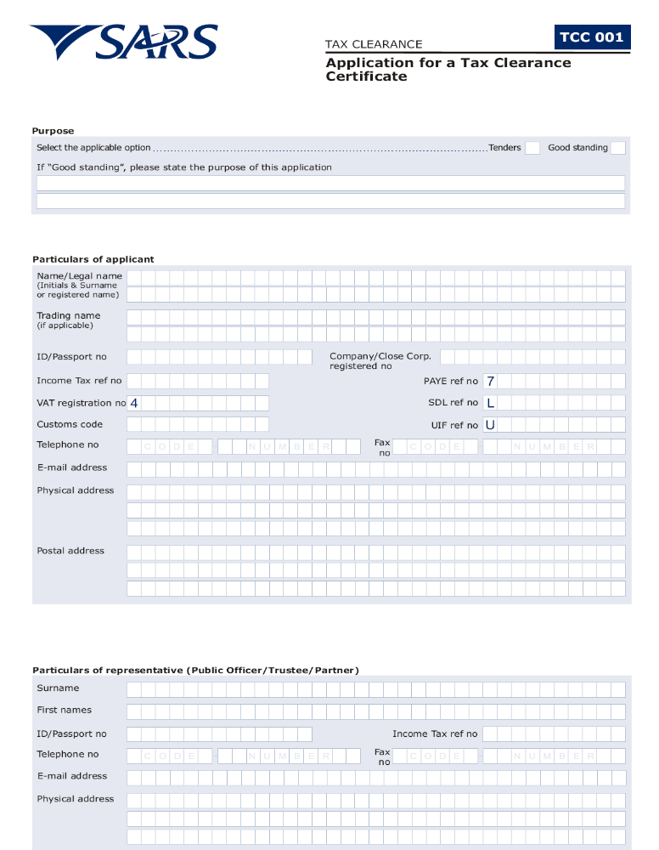
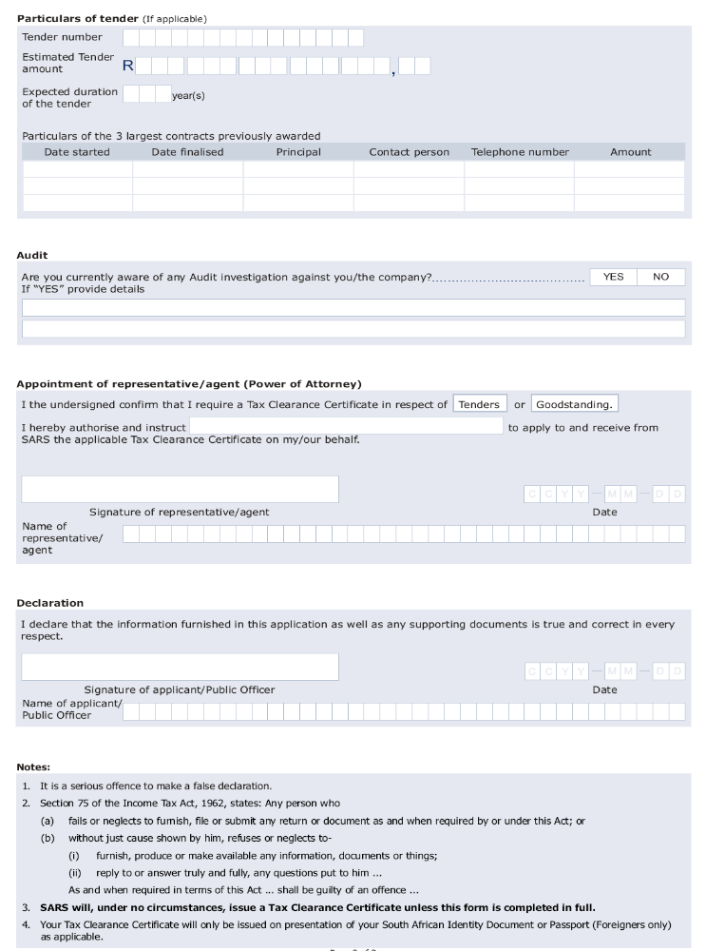

SDB 3.1

PRICING SCHEDULE – FIRM PRICES
(PURCHASES)

NOTE: ONLY FIRM PRICES WILL BE ACCEPTED. NON-FIRM PRICES (INCLUDING PRICES SUBJECT TO RATES OF EXCHANGE VARIATIONS) WILL NOT BE CONSIDERED

IN CASES WHERE DIFFERENT DELIVERY POINTS INFLUENCE THE PRICING, A SEPARATE PRICING SCHEDULE MUST BE SUBMITTED FOR EACH DELIVERY POINT

Name of bidder…………………………………… Bid number: ________

Closing Time 11:00 on ___________________

OFFER TO BE VALID FOR 90 DAYS FROM THE CLOSING DATE OF BID.
__________________________________________________________________________
ITEM QUANTITY DESCRIPTION BID PRICE IN RSA CURRENCY
NO. (INCLUDING VAT)

- Required by: ………………………………….

- At: ………………………………….

…………………………………

- Brand and model ………………………………….

- Country of origin ………………………………….

- Does offer comply with specification? *YES/NO

- If not to specification, indicate deviation(s) ………………………………….

- Period required for delivery ………………………………….
*Delivery: Firm/not firm

- Delivery basis (all delivery costs must be
included in the bid price) ………………………………….

Note: All delivery costs must be included in the bid price, for delivery at the prescribed destination.

*Delete if not applicable

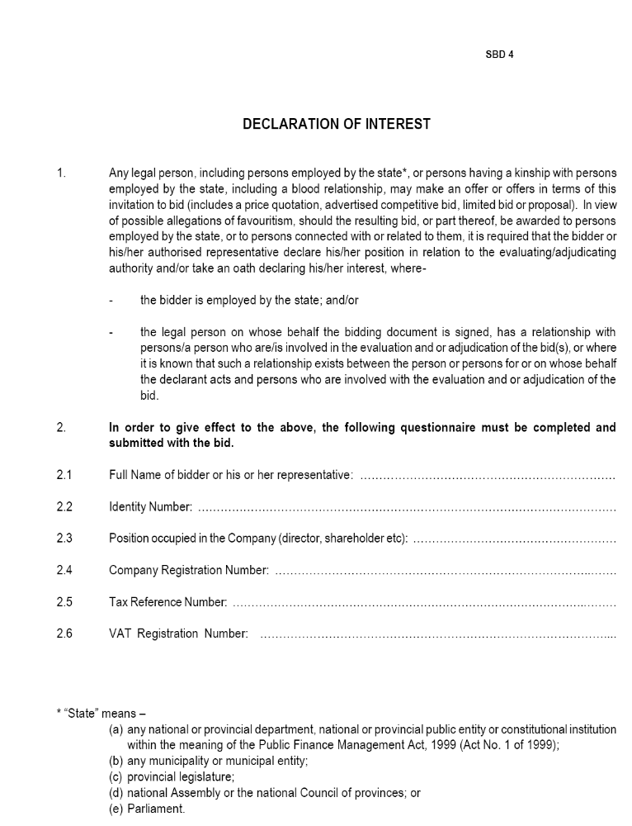
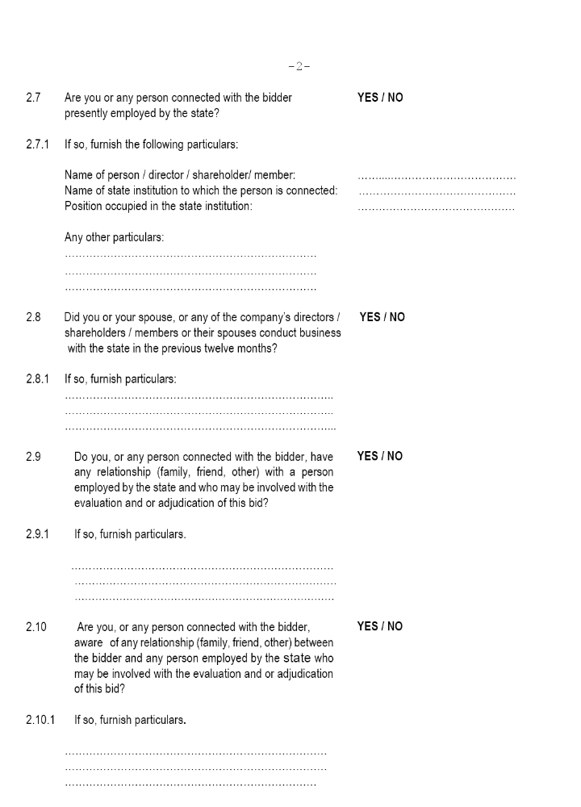
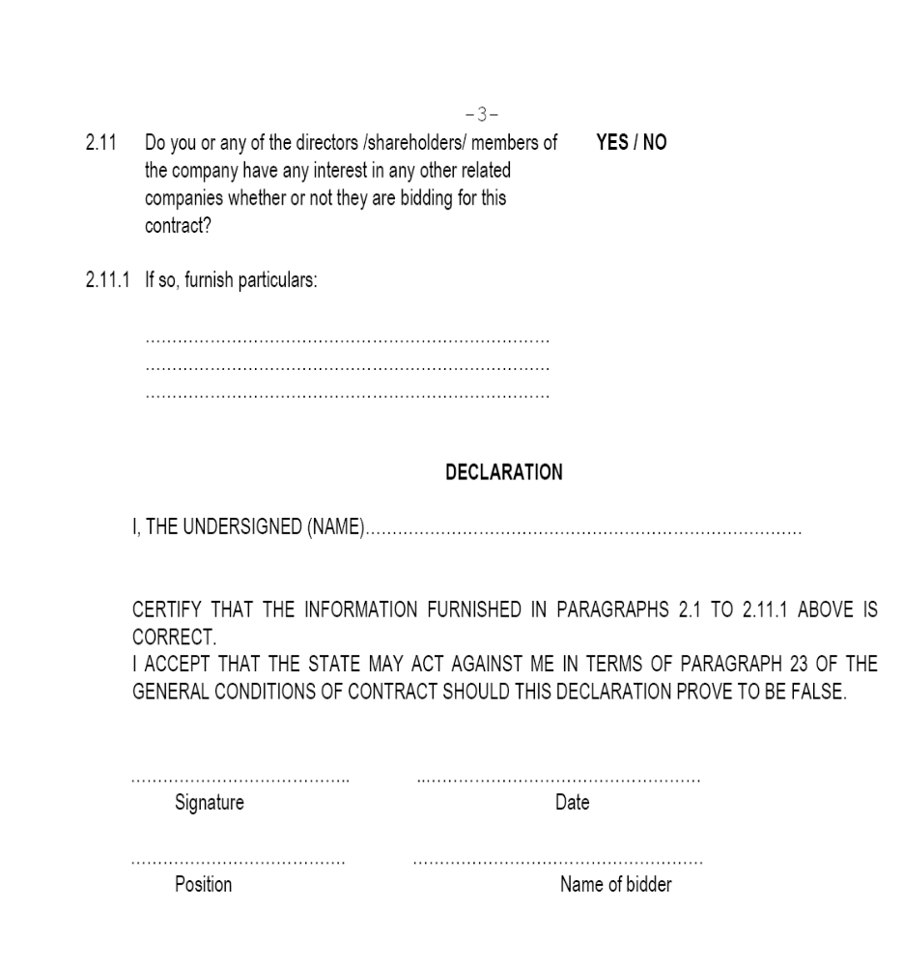
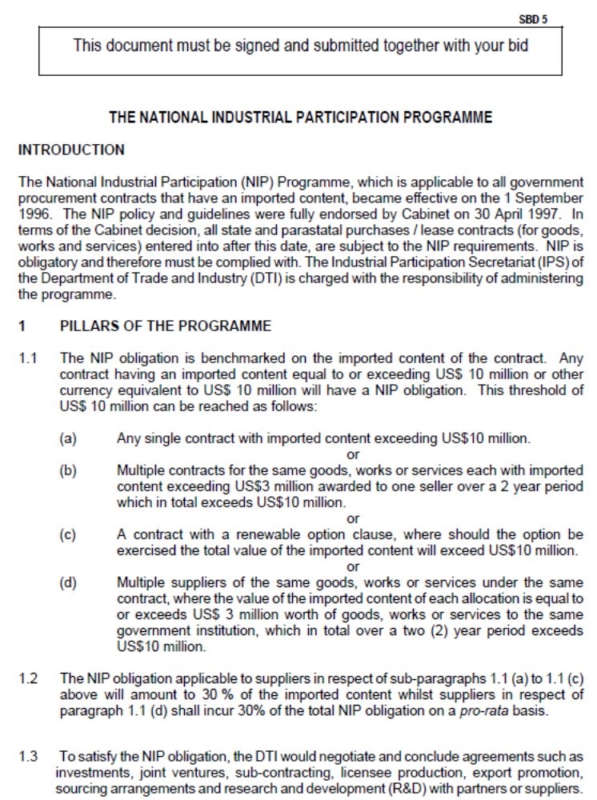
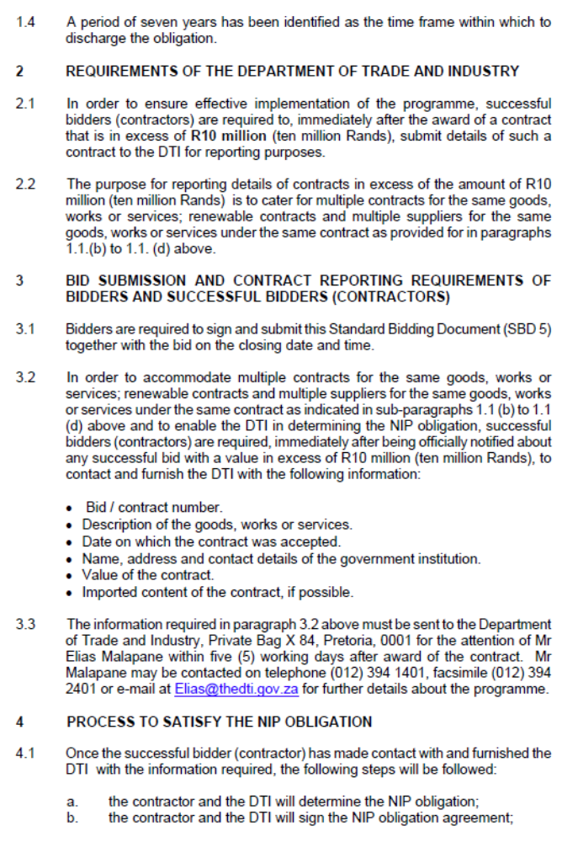
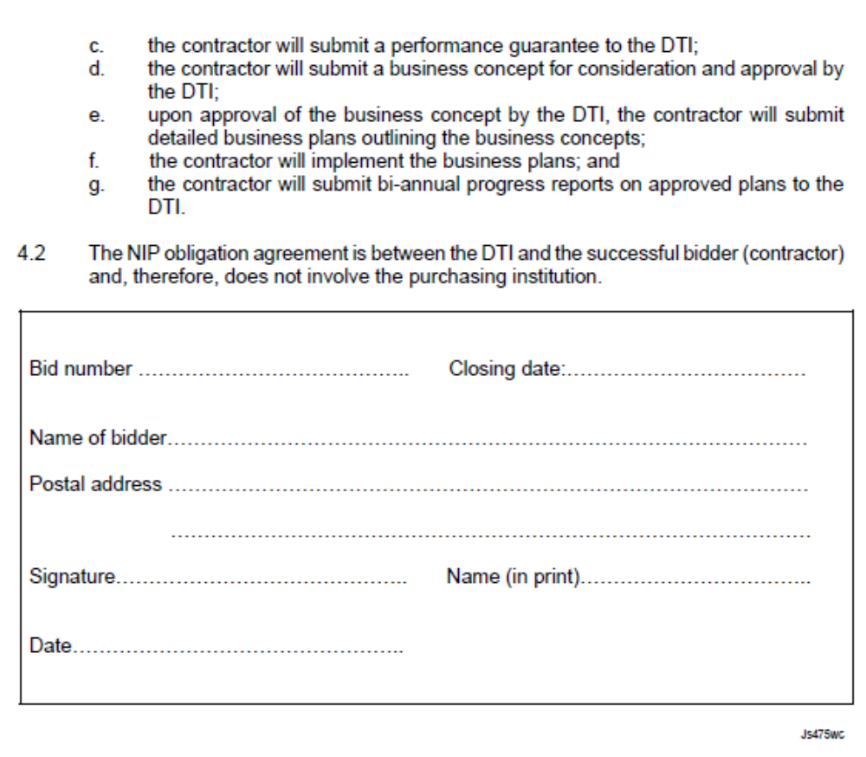

NOTE
SBD 6 TO BE REVISED IN LINE WITH THE EVALUATION CRITERIA INCLUDED IN THE TERMS OF REFERENCE



